Revision Session Test 5 :

Test Duration(8-10 PM)

You have to perform these question on your AWS Account and submit the solution on support@intellipaat.com in pdf format attaching the sufficient screenshots of the task perform on AWS Account.

Ques-1 : Create an s3 bucket and perform the CRR(Cross Region Replication) on this bucket.

Ques-2 : Create a vpc endpoint for s3 bucket and access it using the ec2 instance.

These are the two Question you have to perform and submit your solutions.

ANS 1:

Create S3 Buckets in Different Regions

Log in to the AWS Management Console and navigate to the S3 service.

Create a new bucket in your desired source region ( us-east-1). Give it a unique name and configure any necessary settings (public/private access).

Create another bucket in a different region (us-west-2) to be your destination for replication.

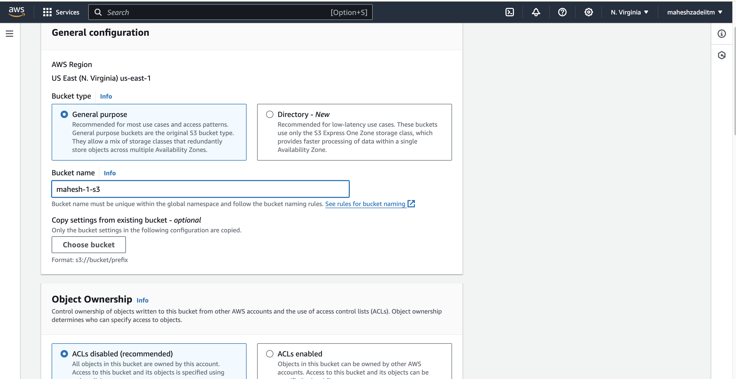

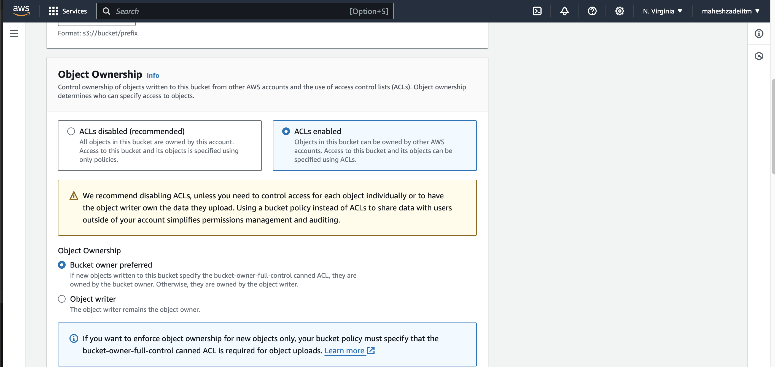

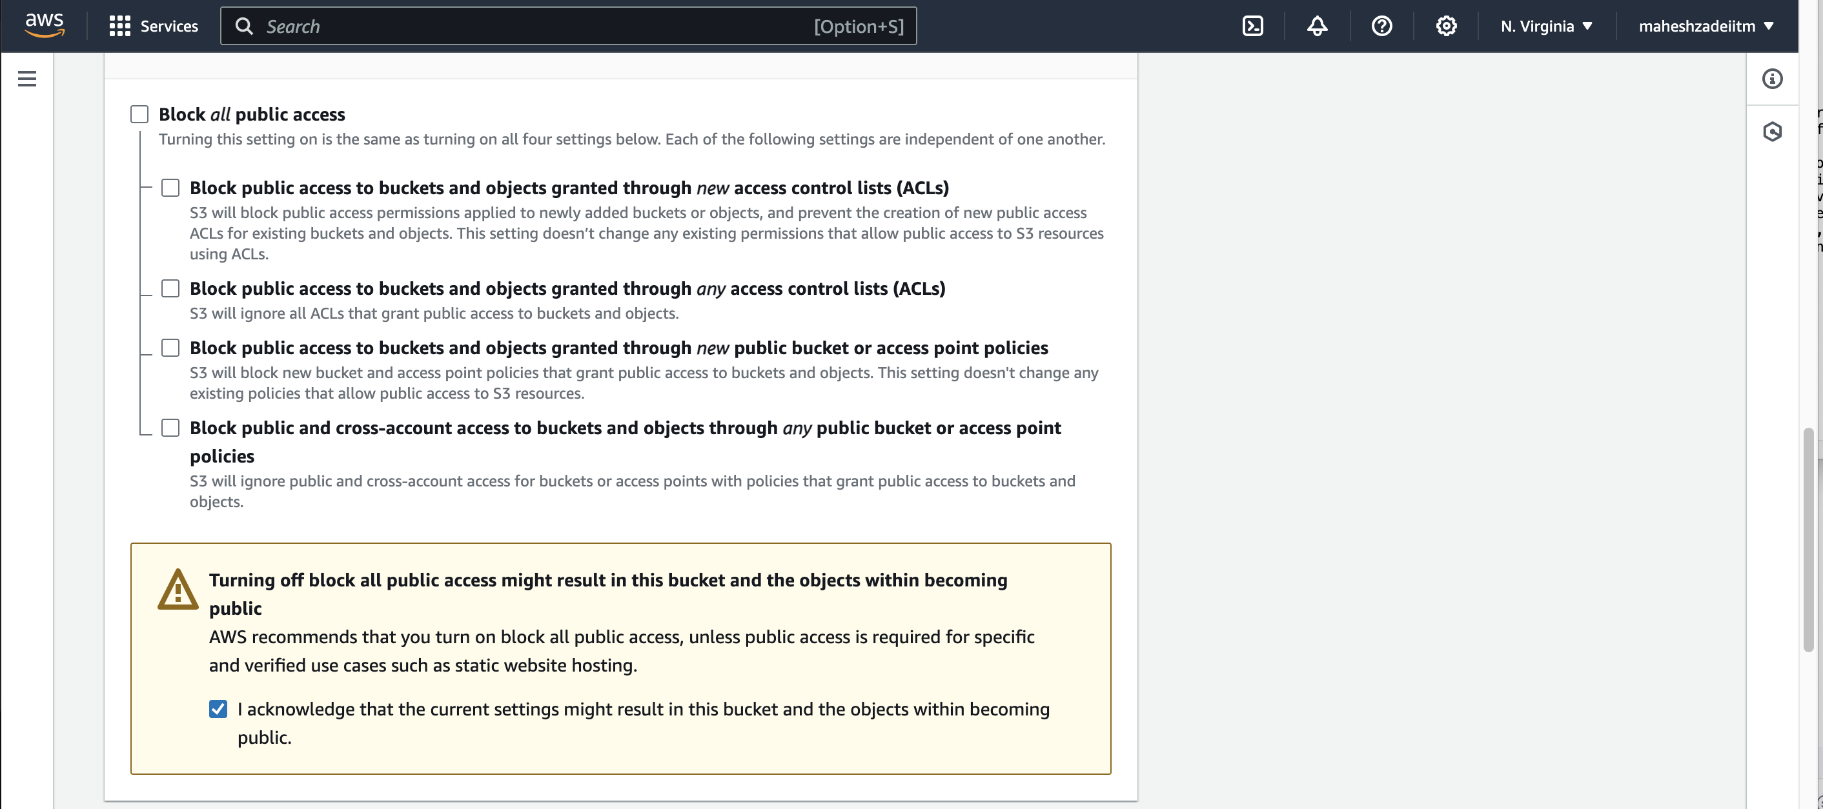

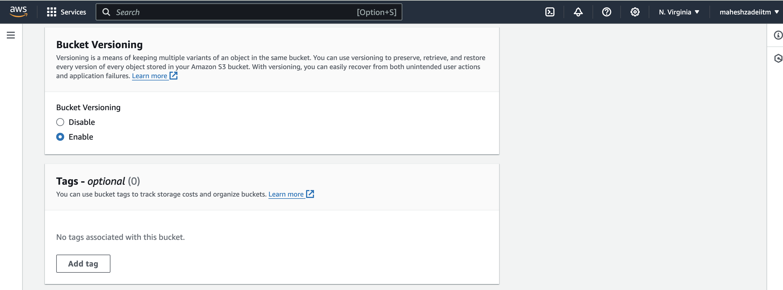

Click on create bucket

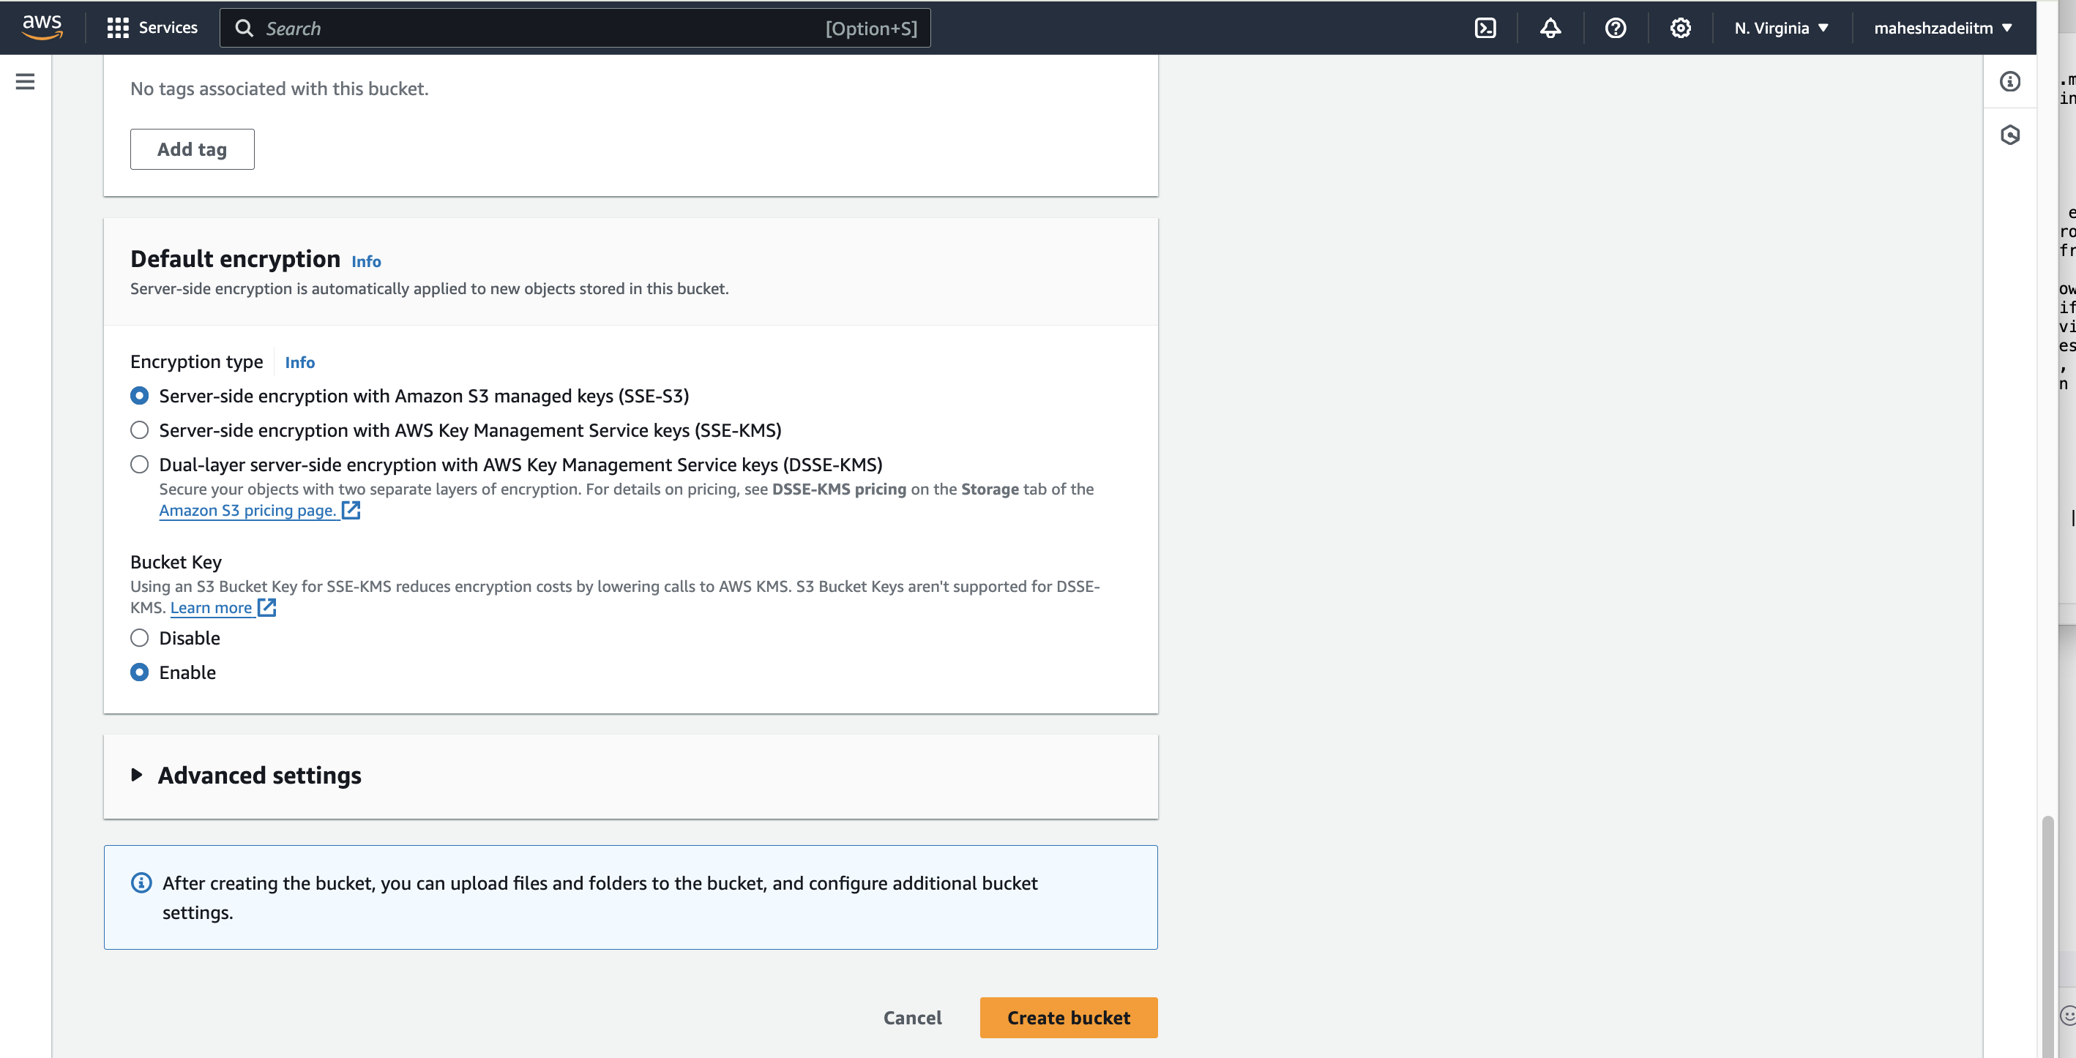

Bucket create in N verginia Region

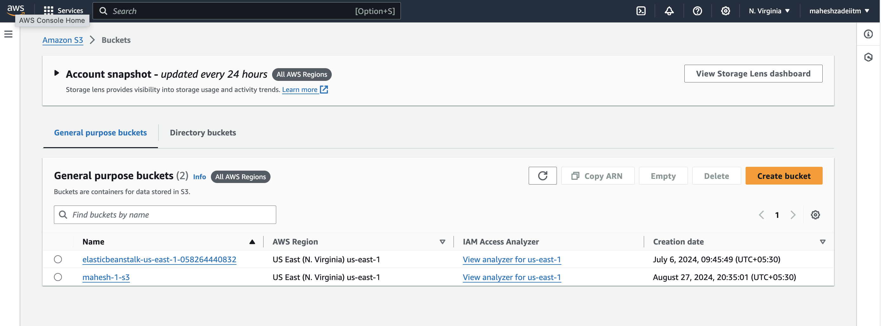

Create another bucket in a different region (us-west-2) to be your destination for replication.

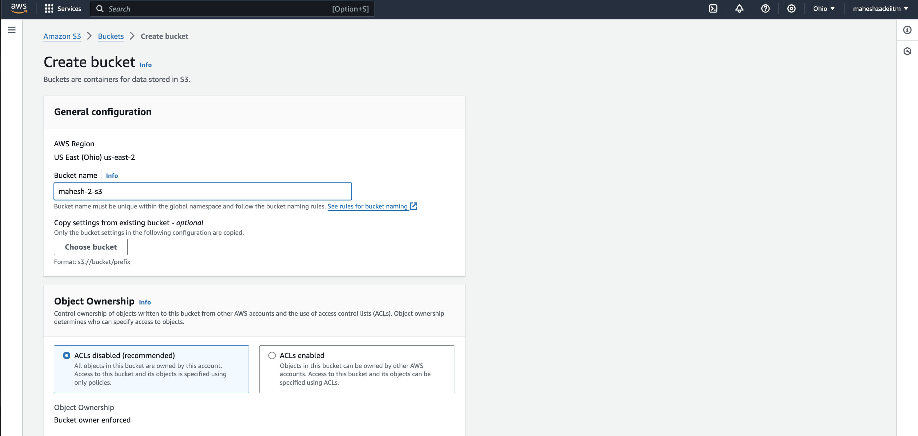

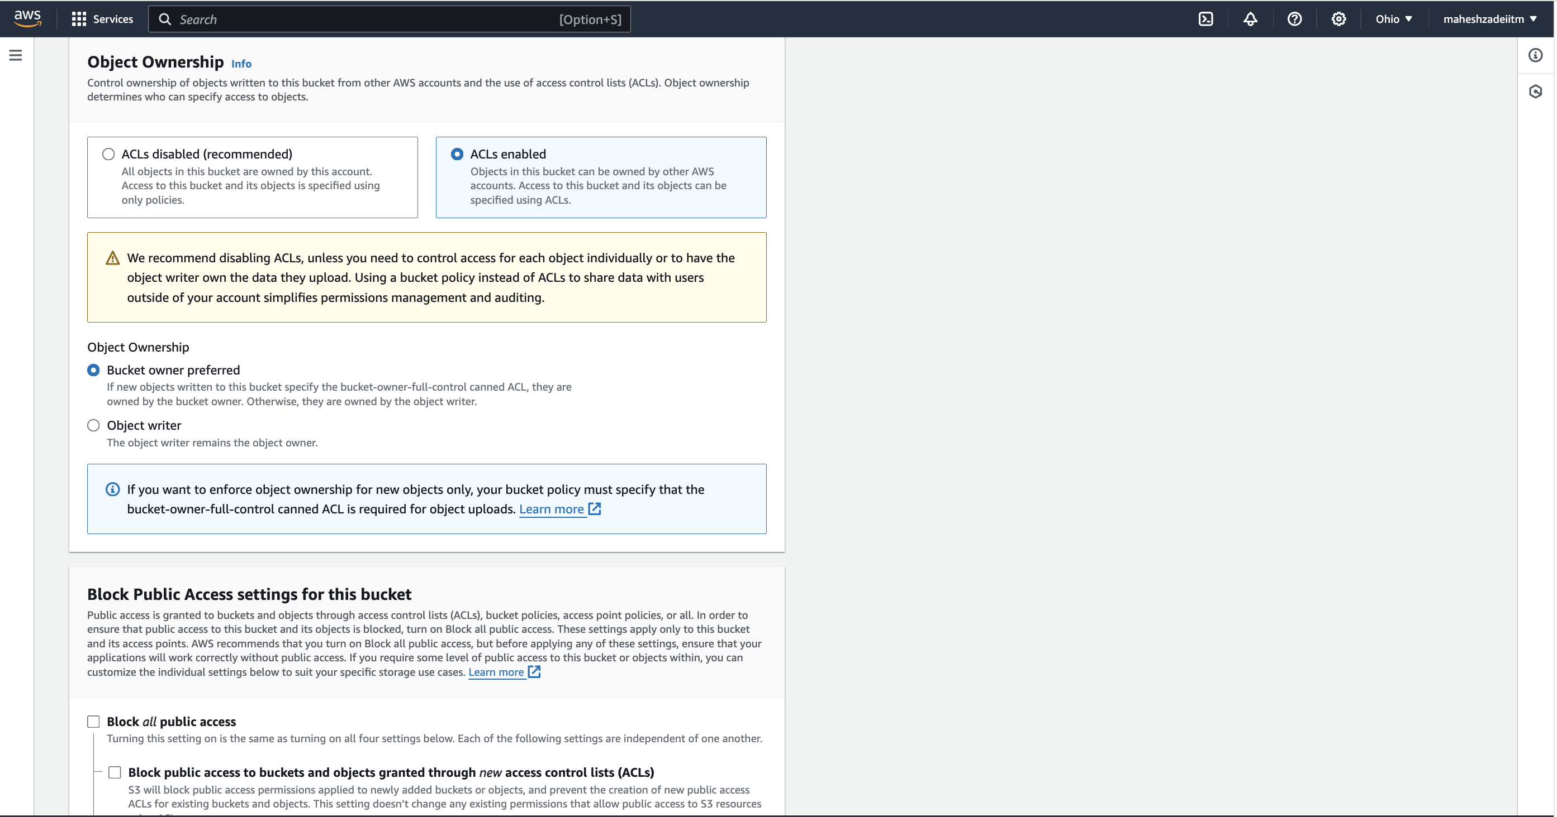

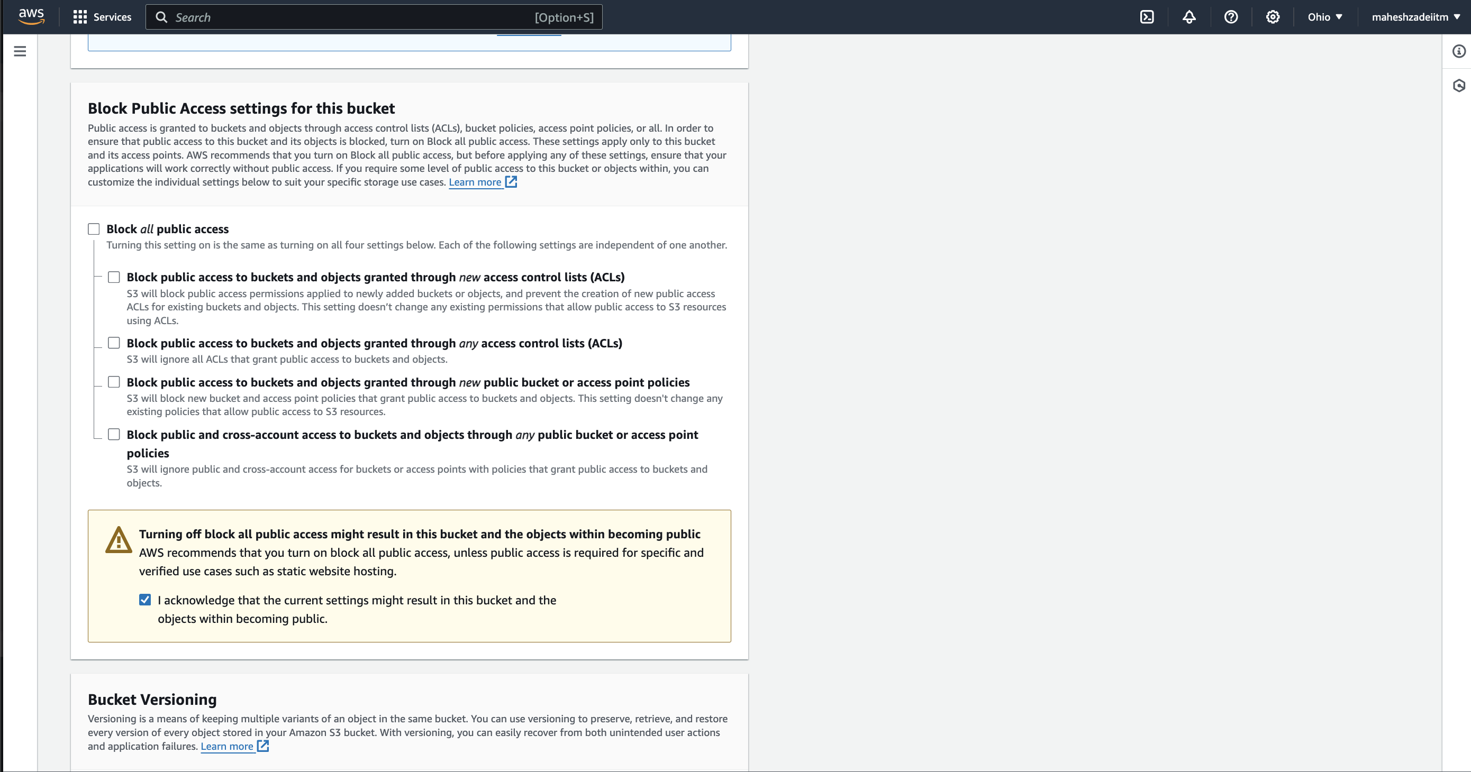

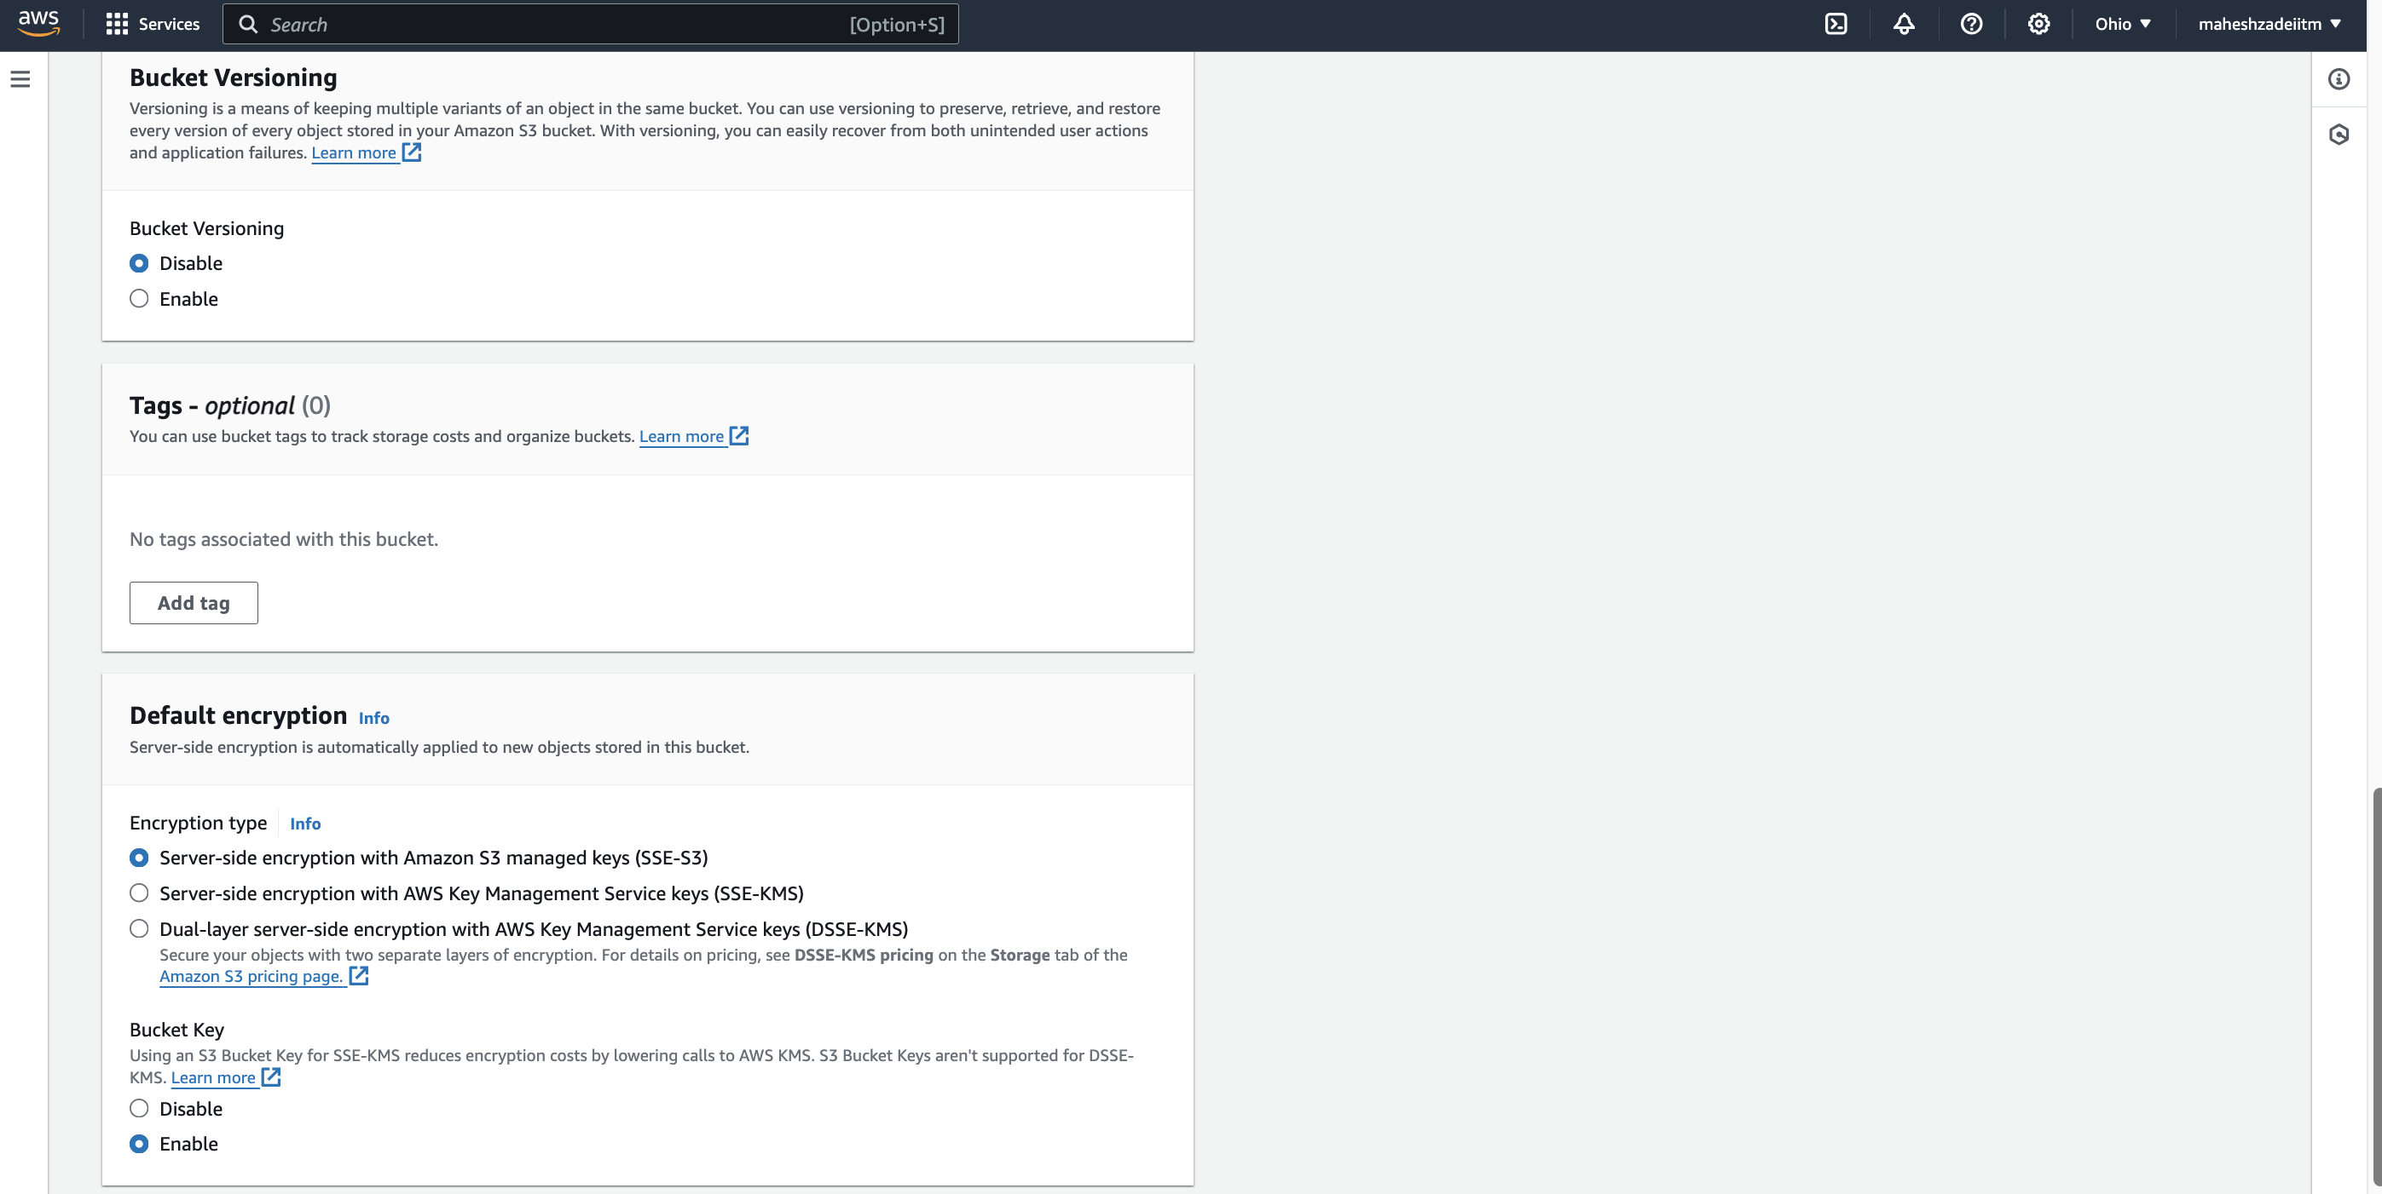

Click on Create Bucket

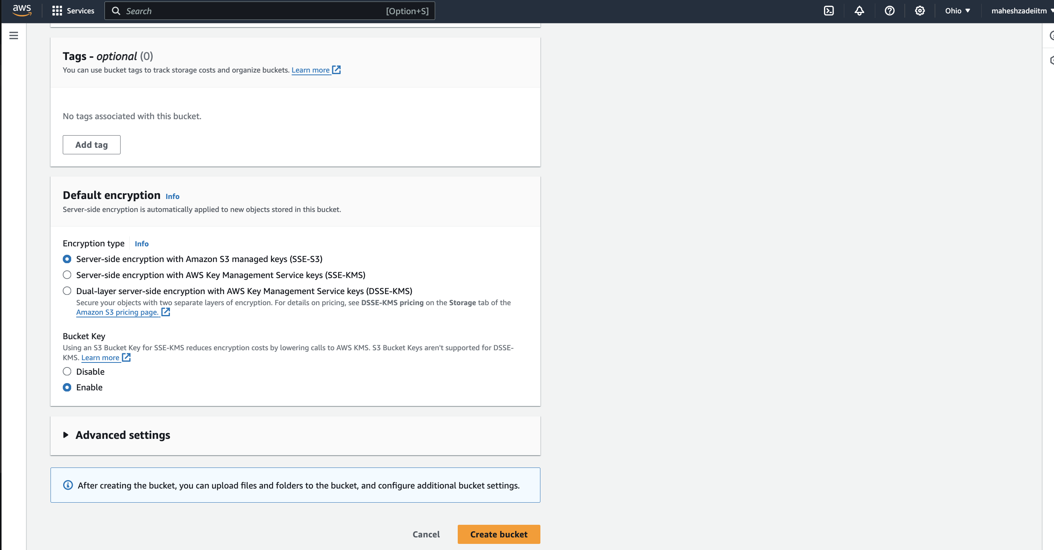

Both Regions Bucket created

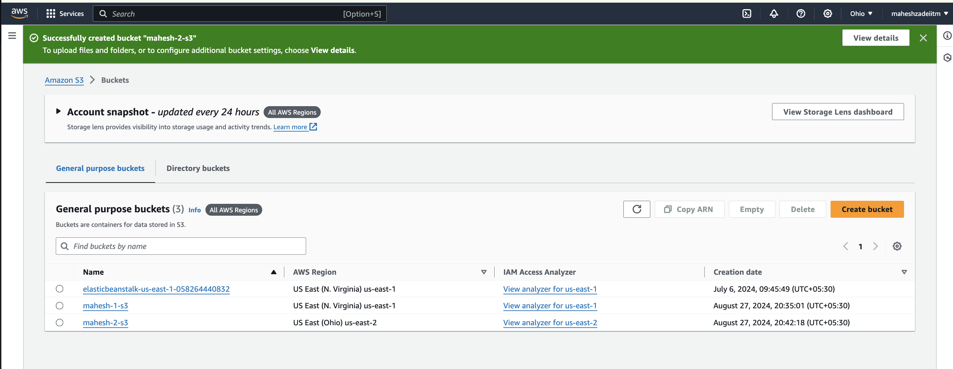

Enabled Versioning on Both Buckets

This is crucial for CRR as it allows for tracking and restoring previous versions of objects.

Now

Create an IAM Role for S3 Replication

Go to the IAM service in the AWS Management Console.

Create a new role.

Choose S3 as the trusted entity and select the AmazonS3ReadOnlyAccess policy.

Attach this role to the source bucket's policy.

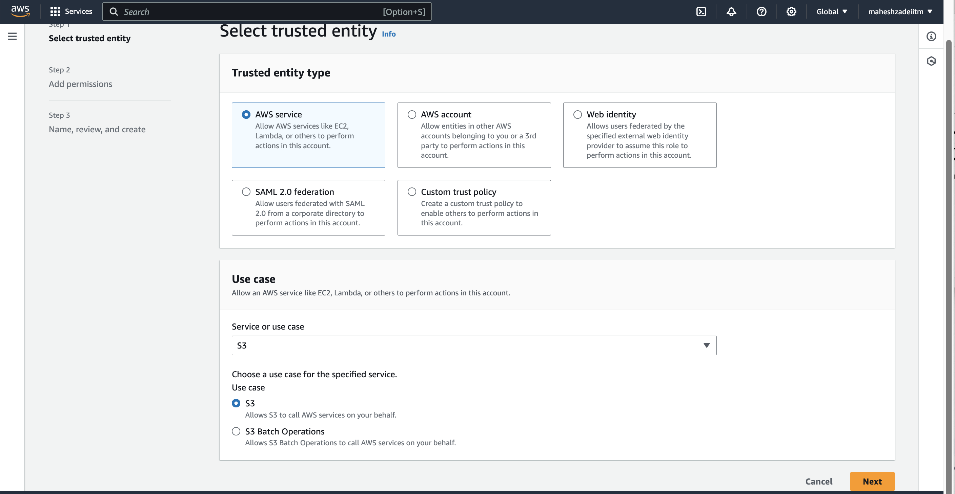

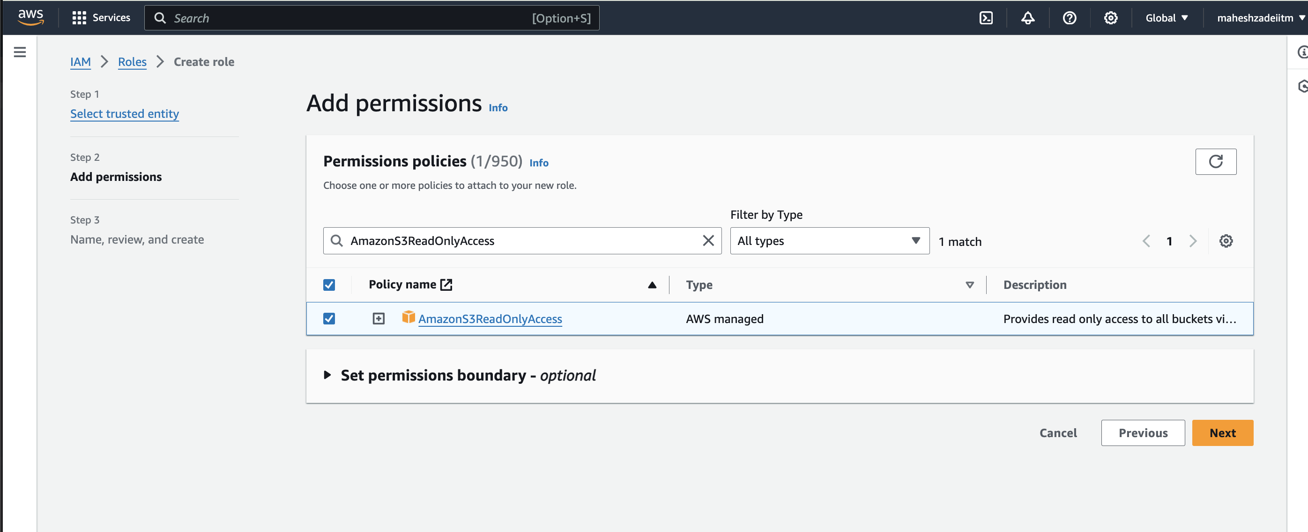

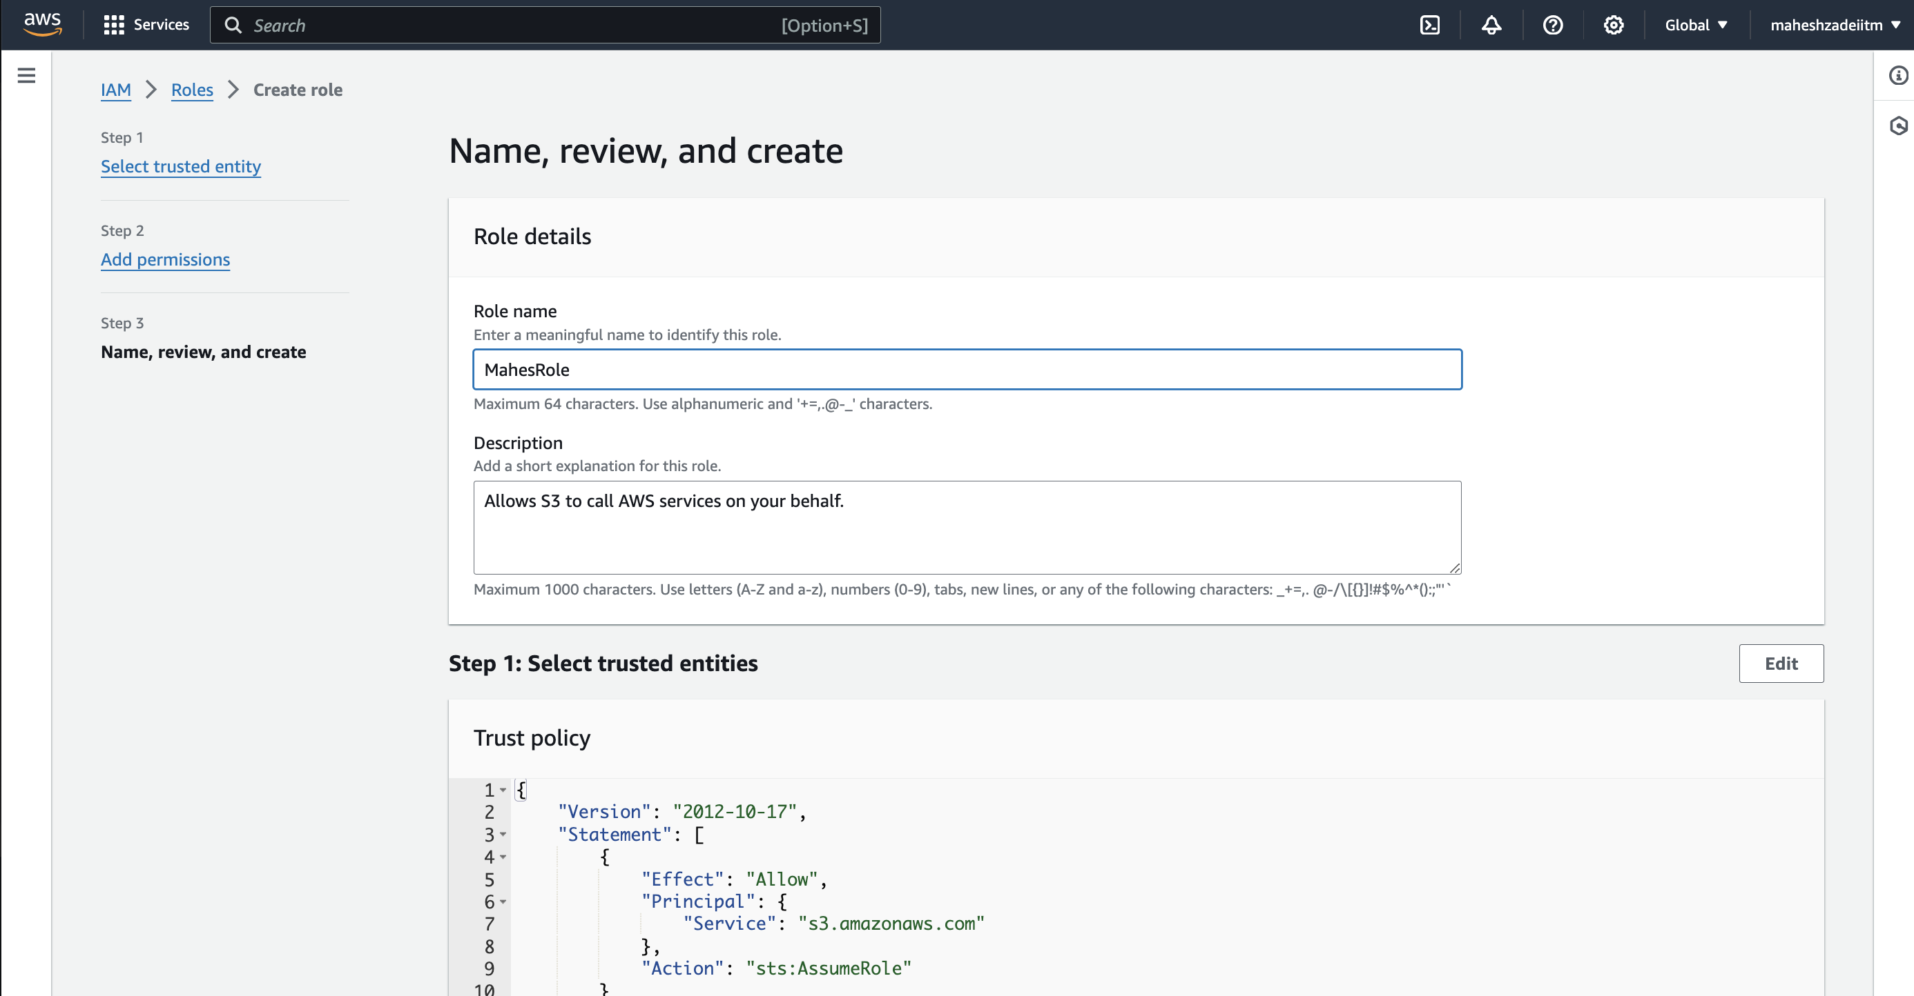

Click on create Role

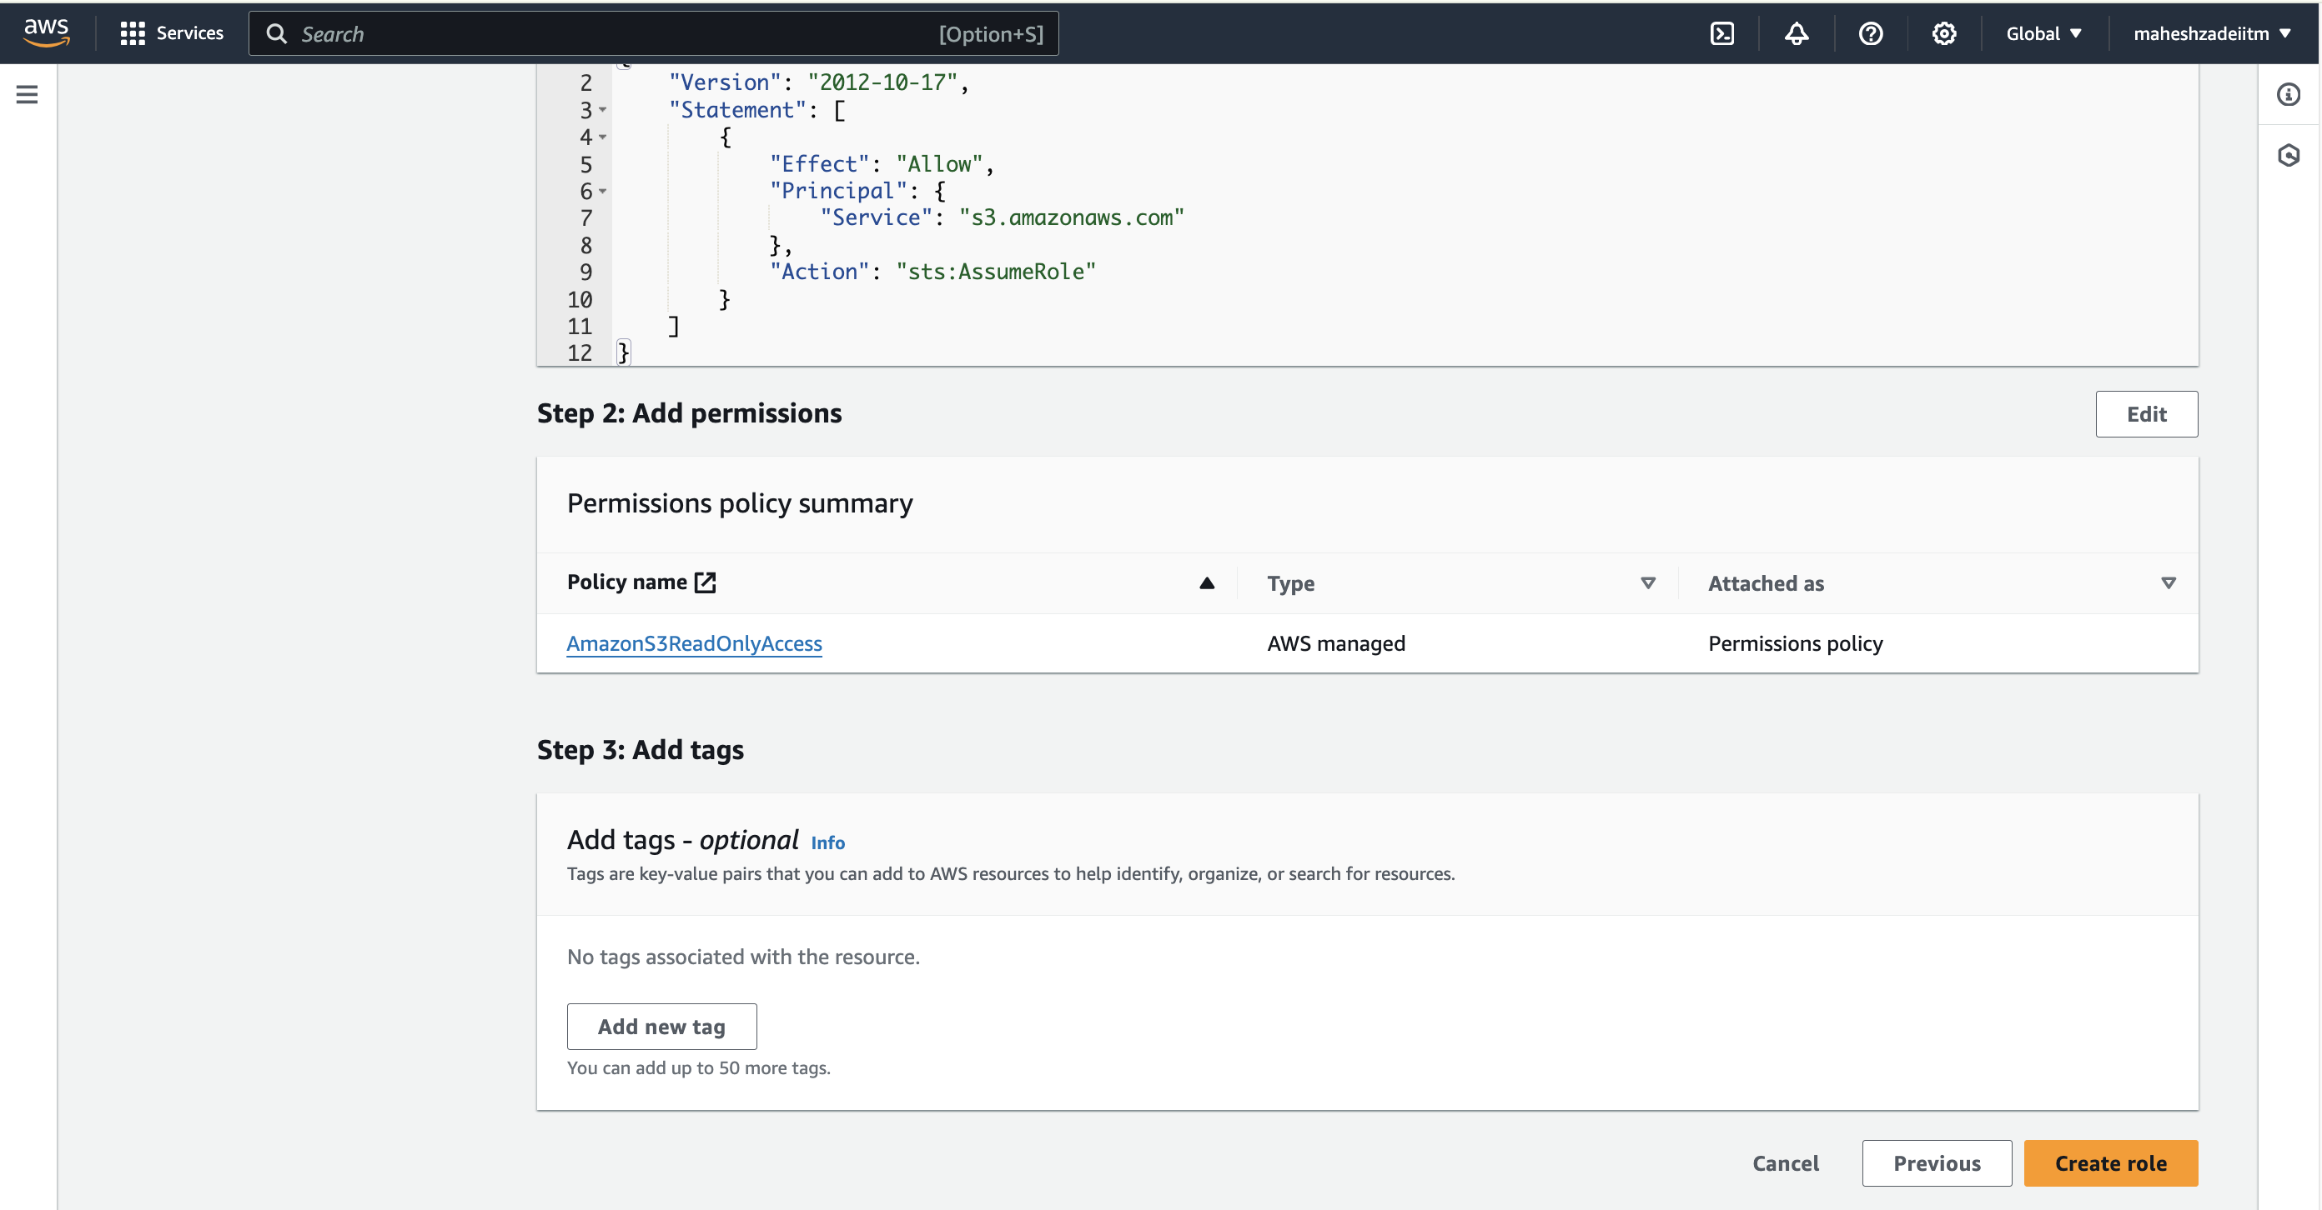

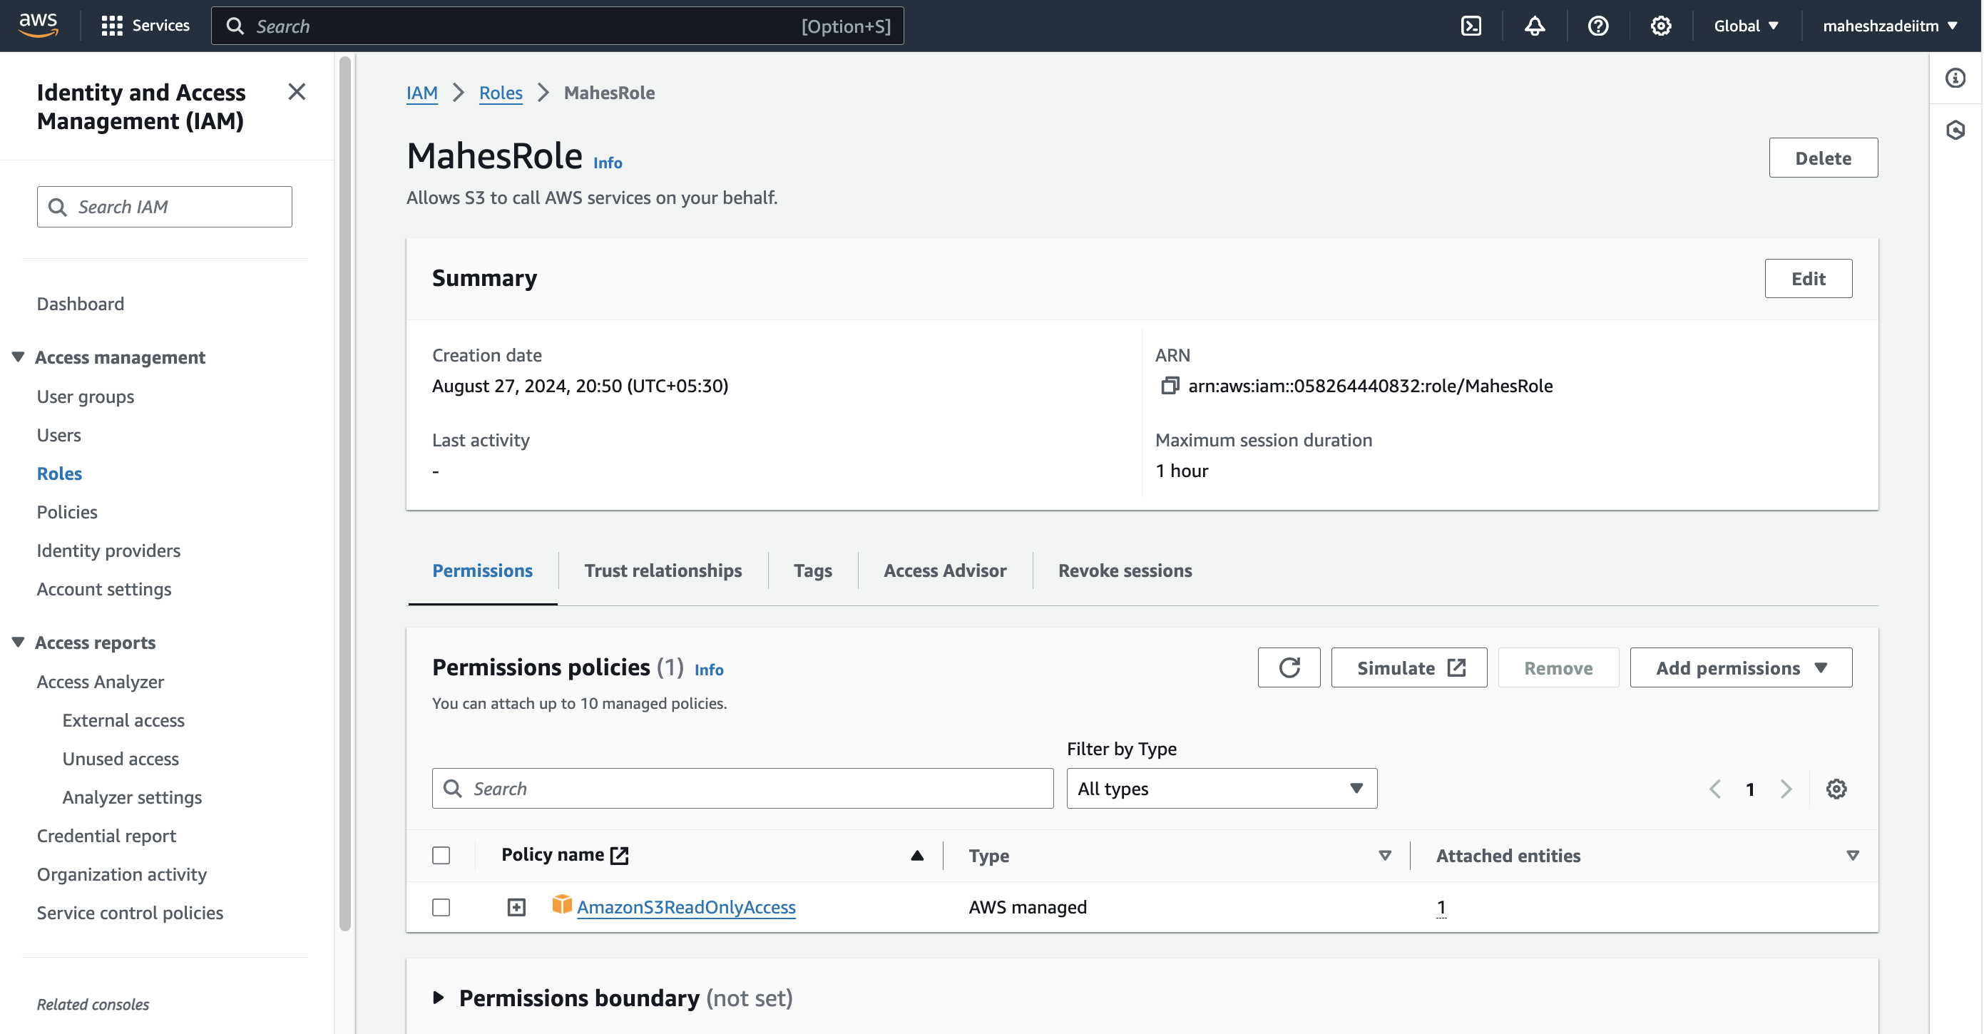

To attach the IAM role to the source bucket's policy, follow these steps:

1. **Navigate to the Properties** tab of your source bucket in the S3 console.
2. **Go to the Permissions** section.
3. **Click on the "Bucket Policy"** tab.
4. **Paste the following JSON policy** into the editor, replacing mahesh-1-s3 with the actual name of your source bucket and arn:aws:s3:::mahesh-1-s3 with the ARN of the IAM role you created:

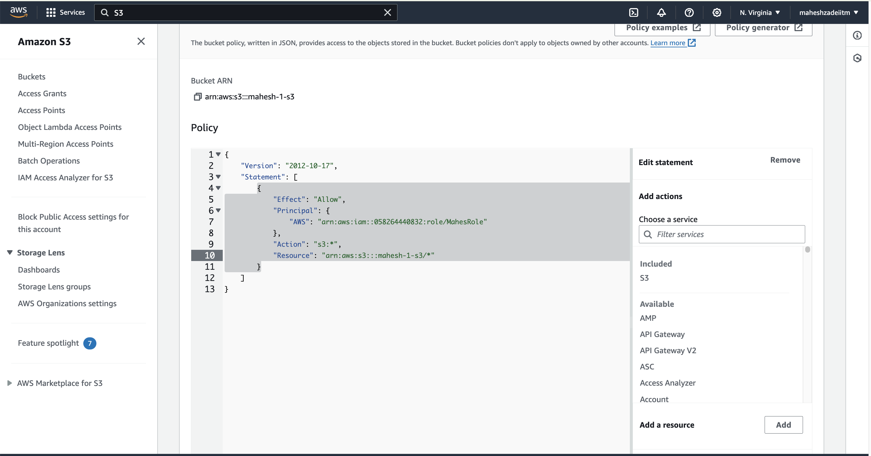

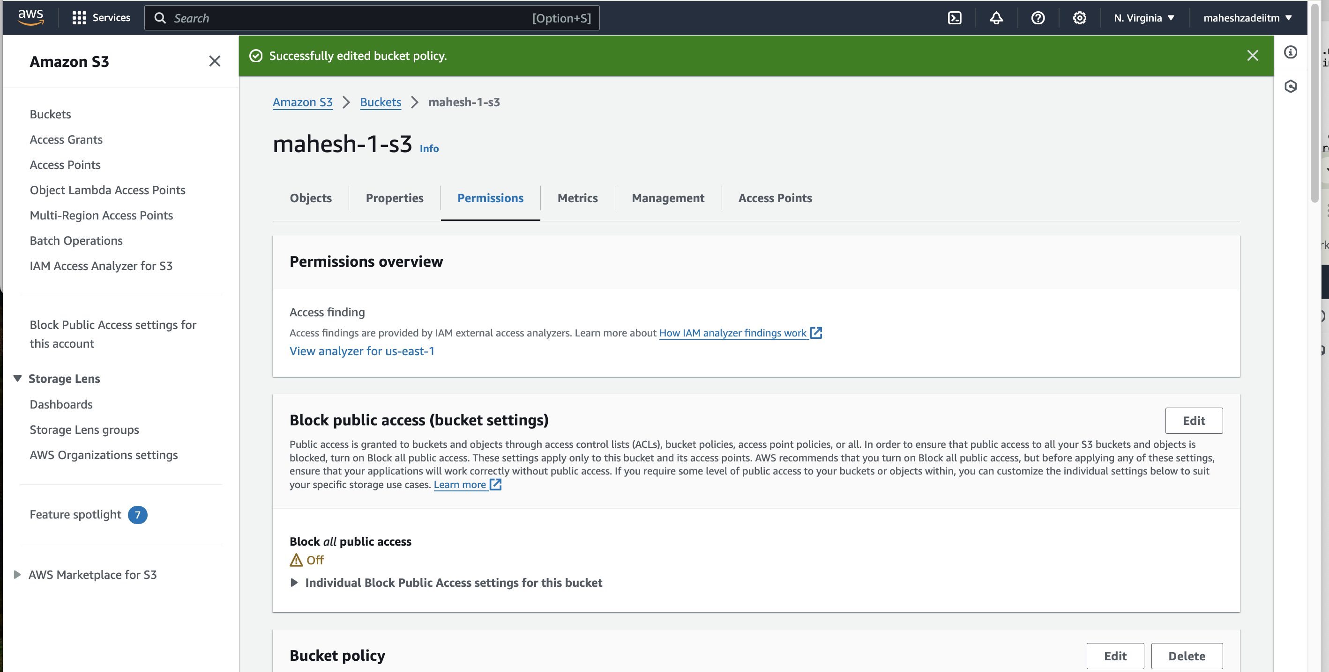

**Configure Cross-Region Replication Rule**

1. **Navigate to the Properties** tab of your source bucket.
2. **Go to the Replication** section.

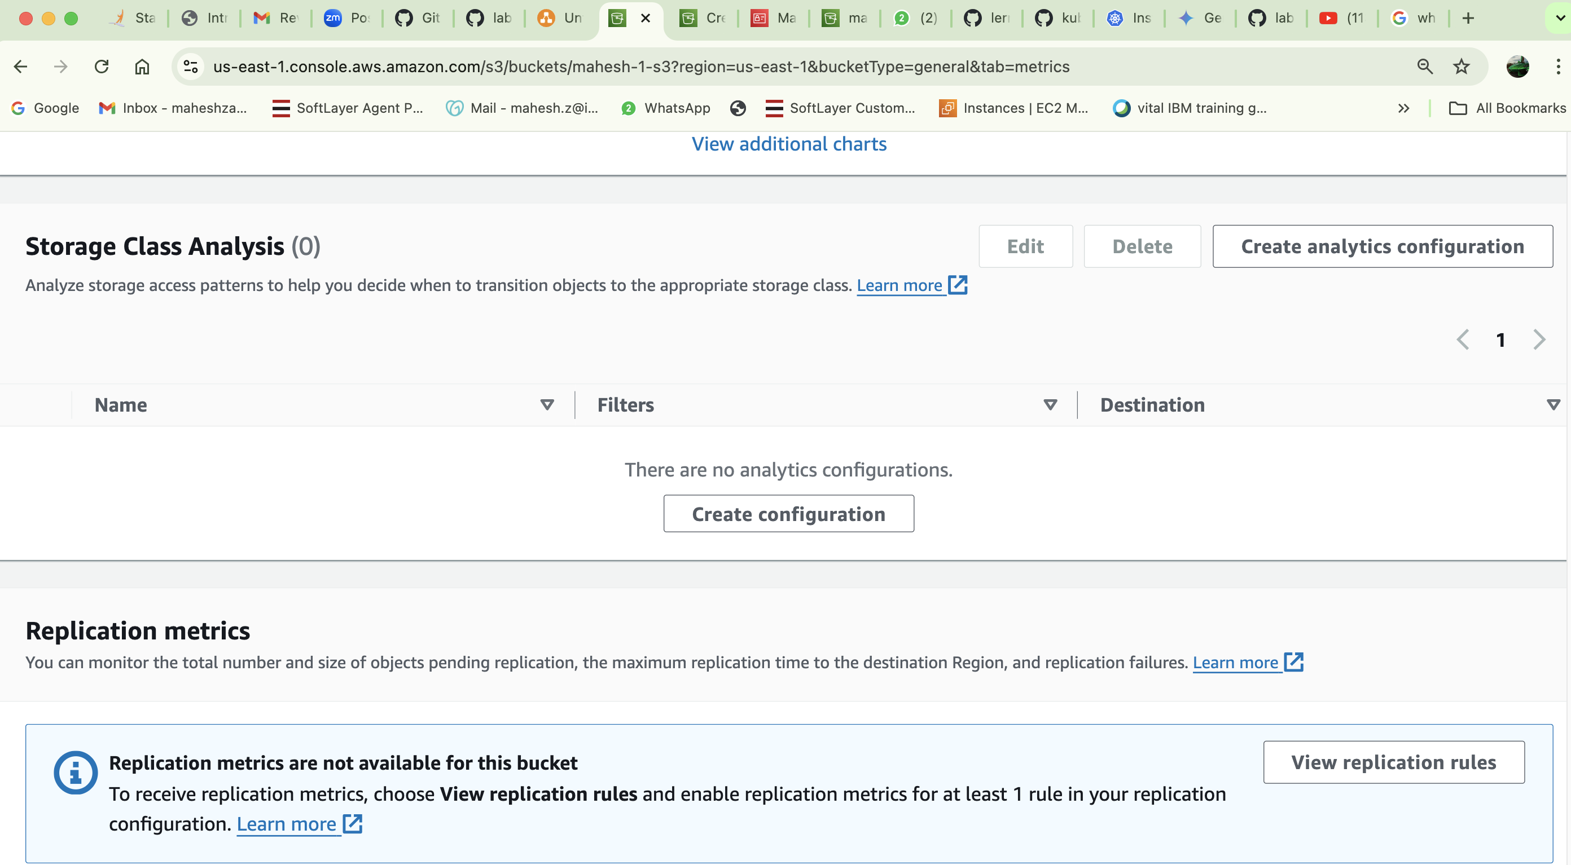

1. **Create a new replication rule**.
2. **Set the destination bucket** and region.
3. **Choose the status** to "Enabled" to activate replication.

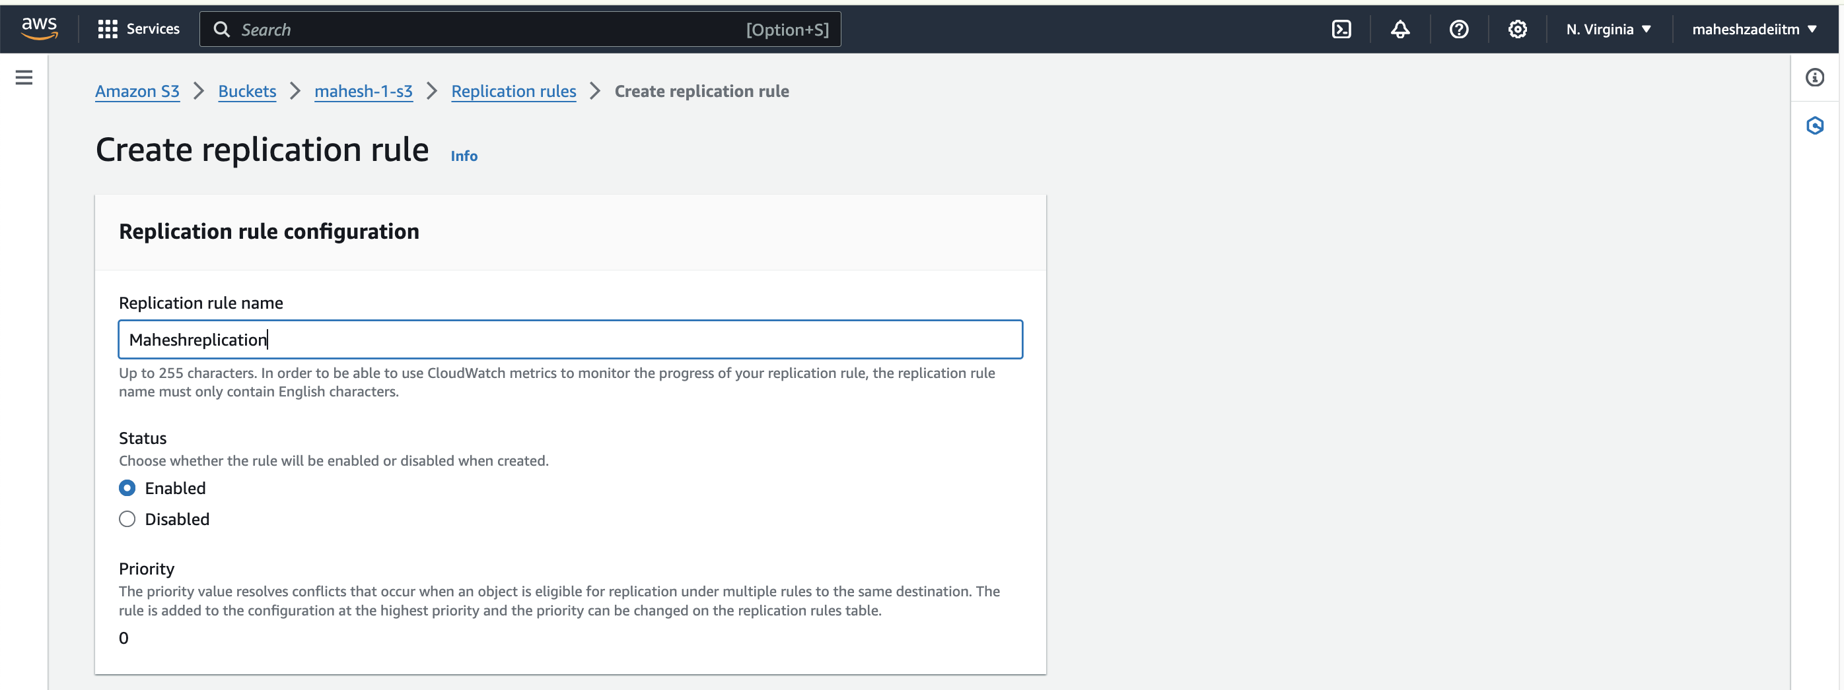

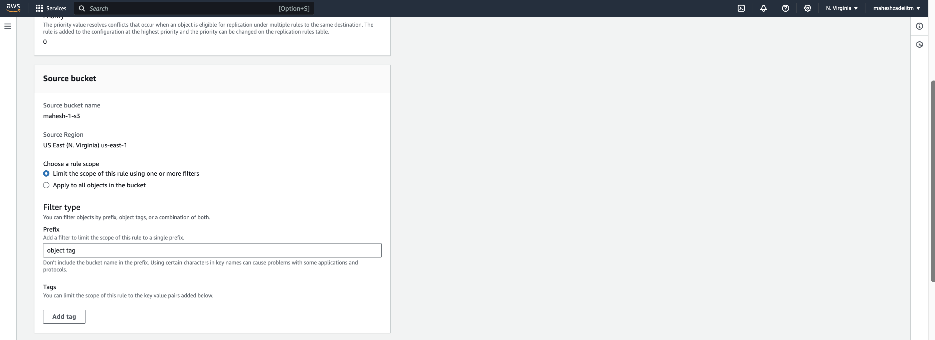

ˇ 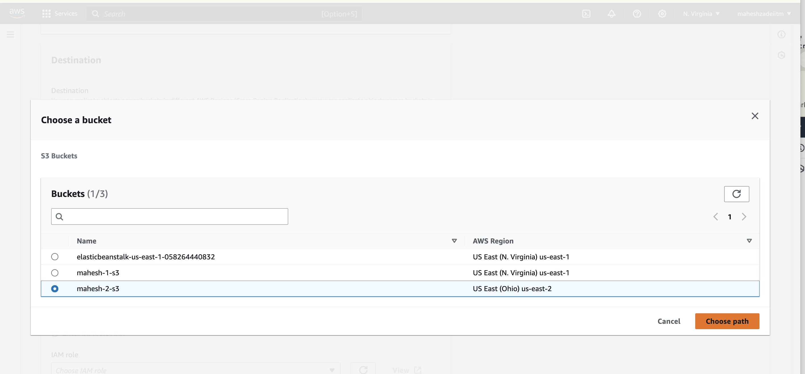



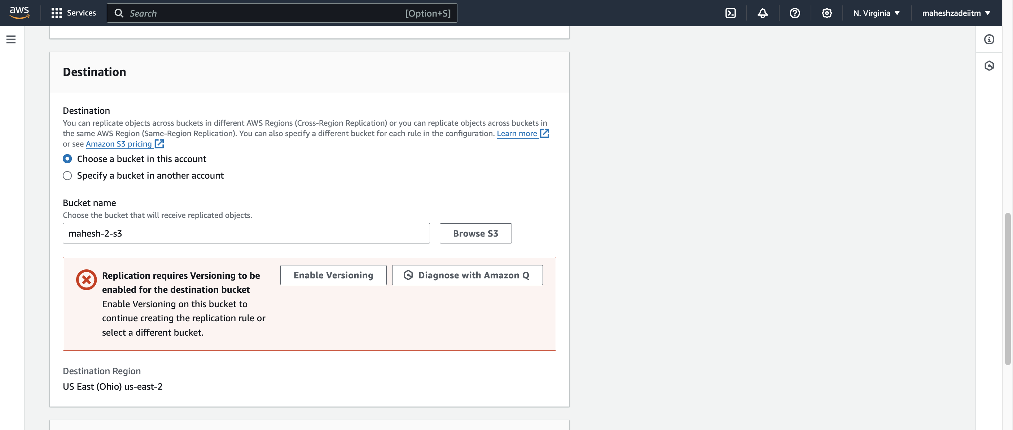

Enable versioing

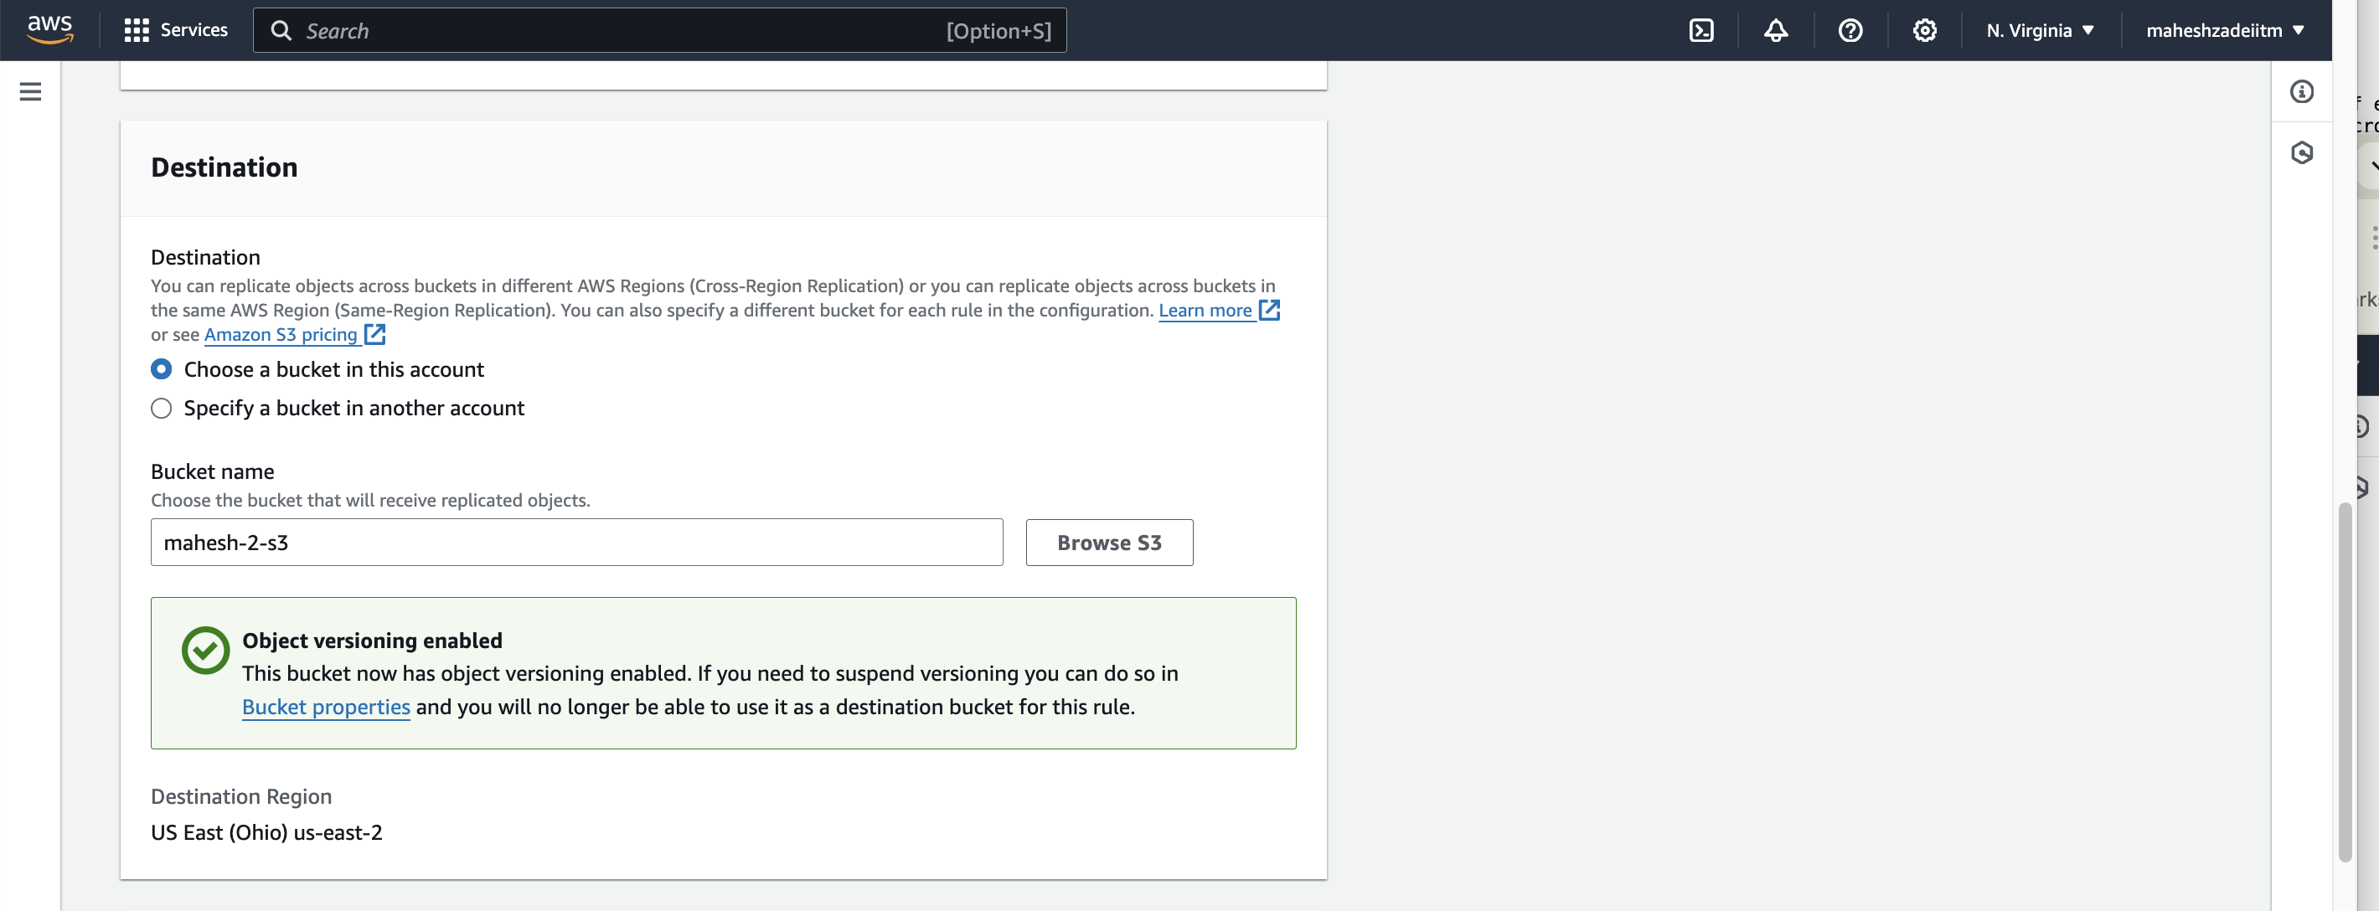

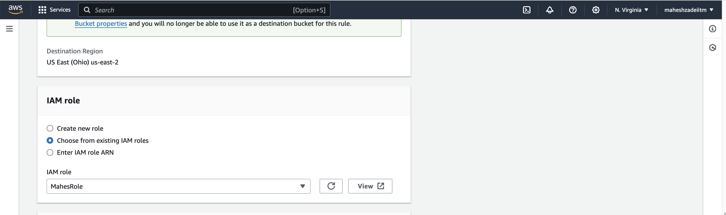

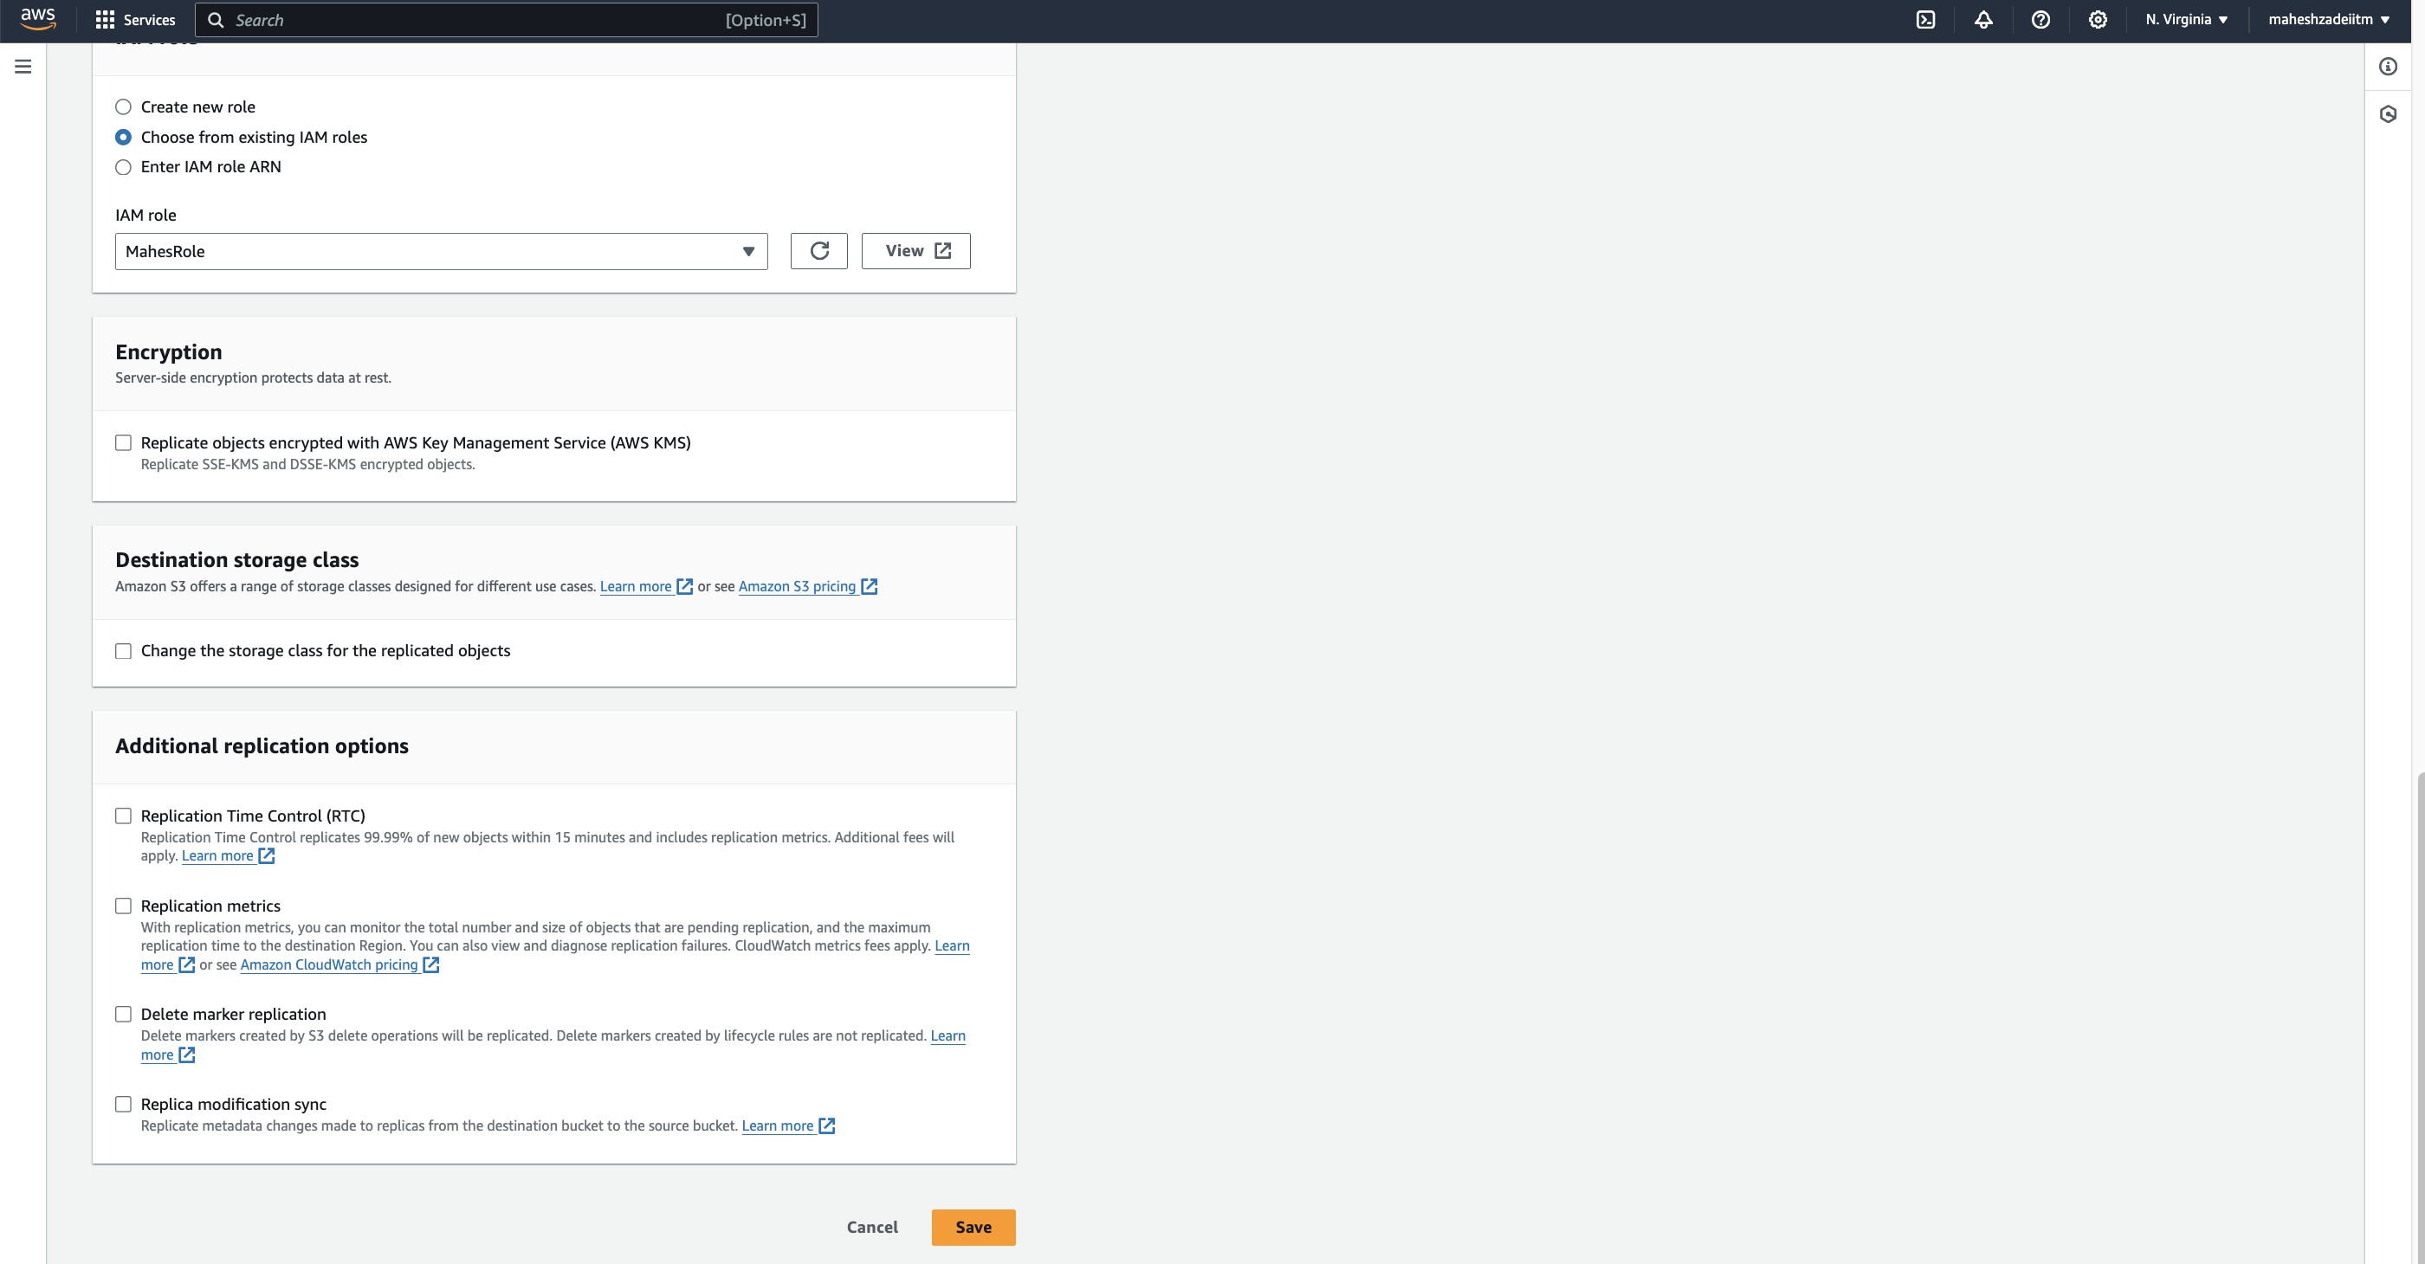

Click on Save

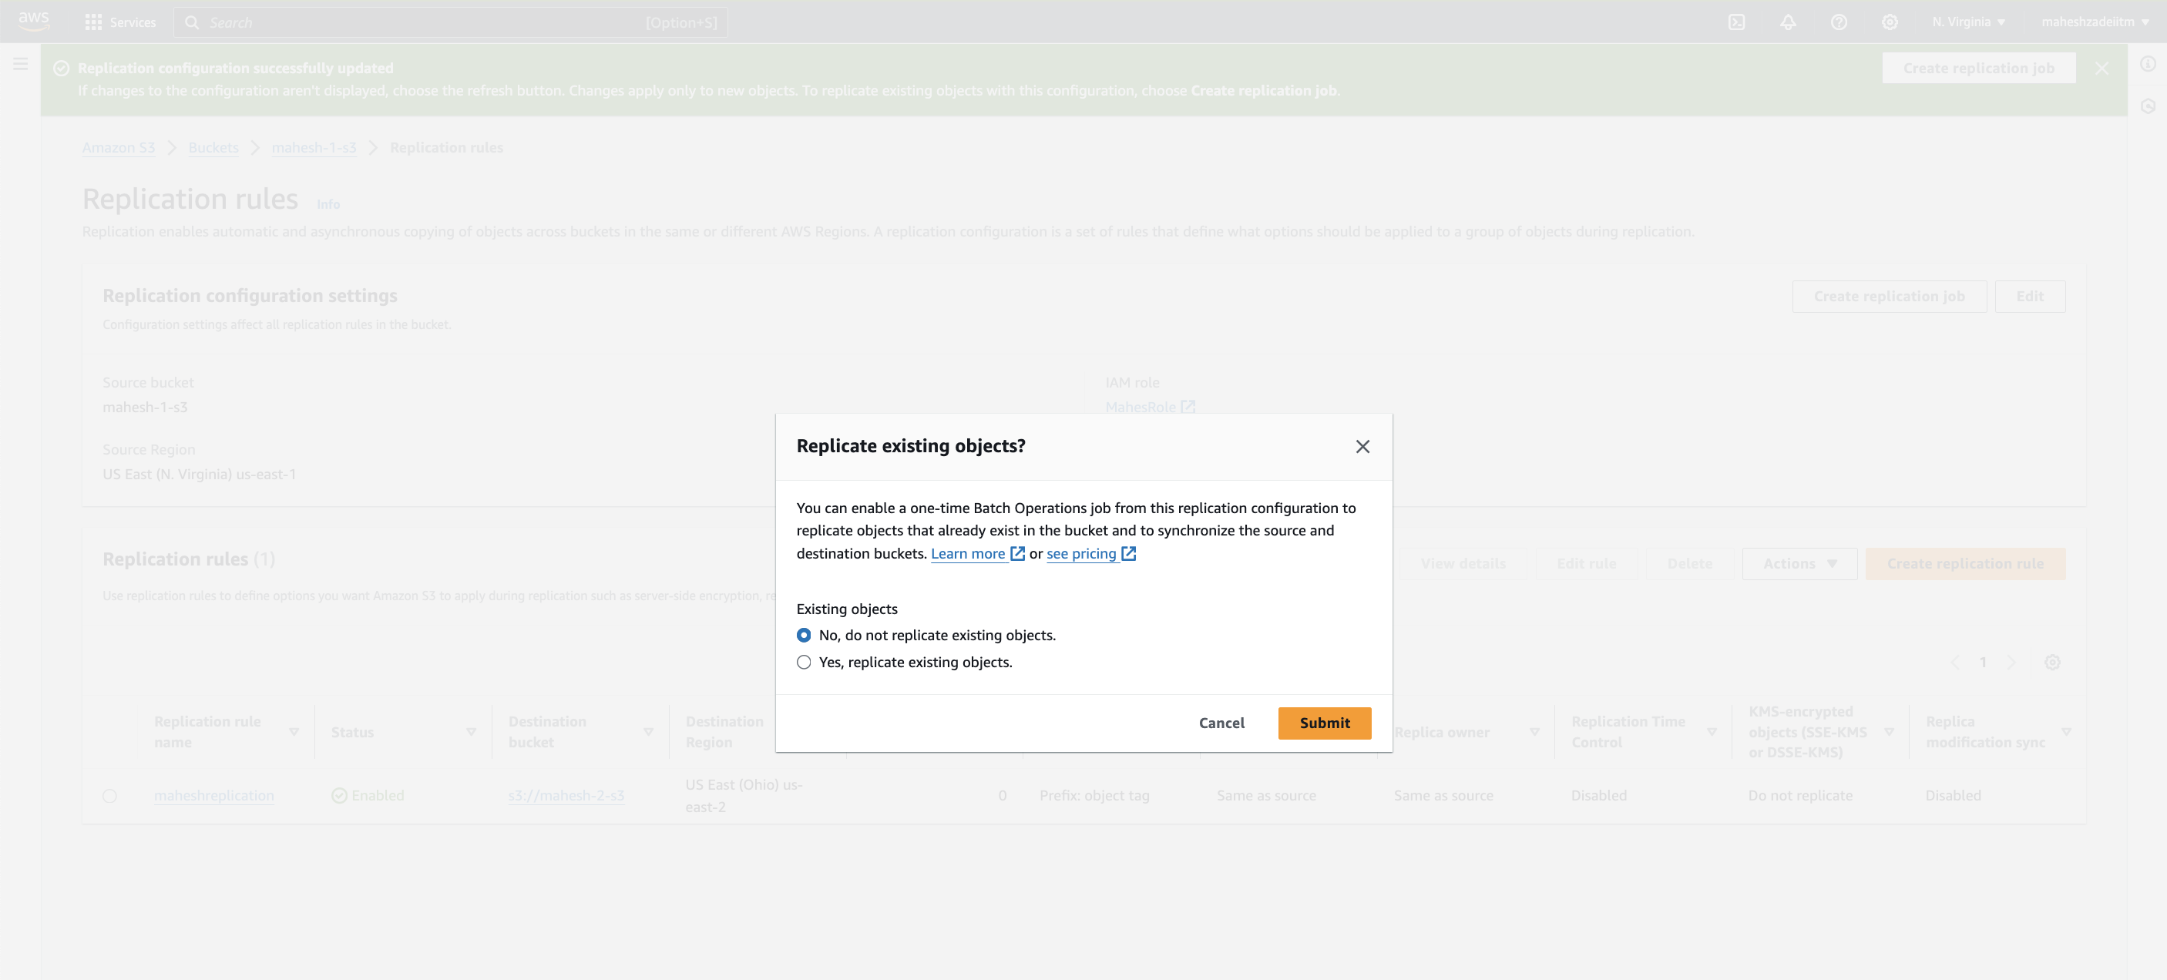

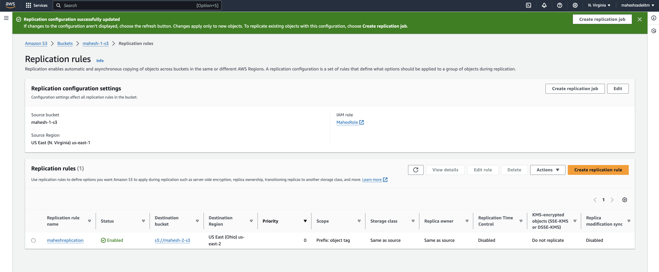

CRR is eventually consistent, meaning there might be a delay between when an object is modified in the source bucket and when it appears in the destination bucket.